DASHBOARD & STORY SCREENSHOTS WITH TABLEAU PUBLIC LINK:

DASHBOARD:

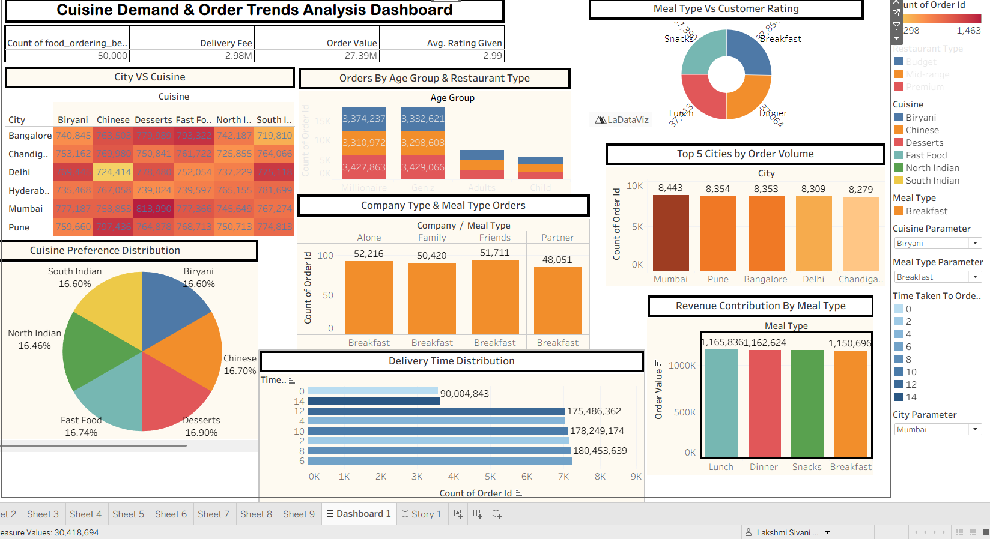

STORY:
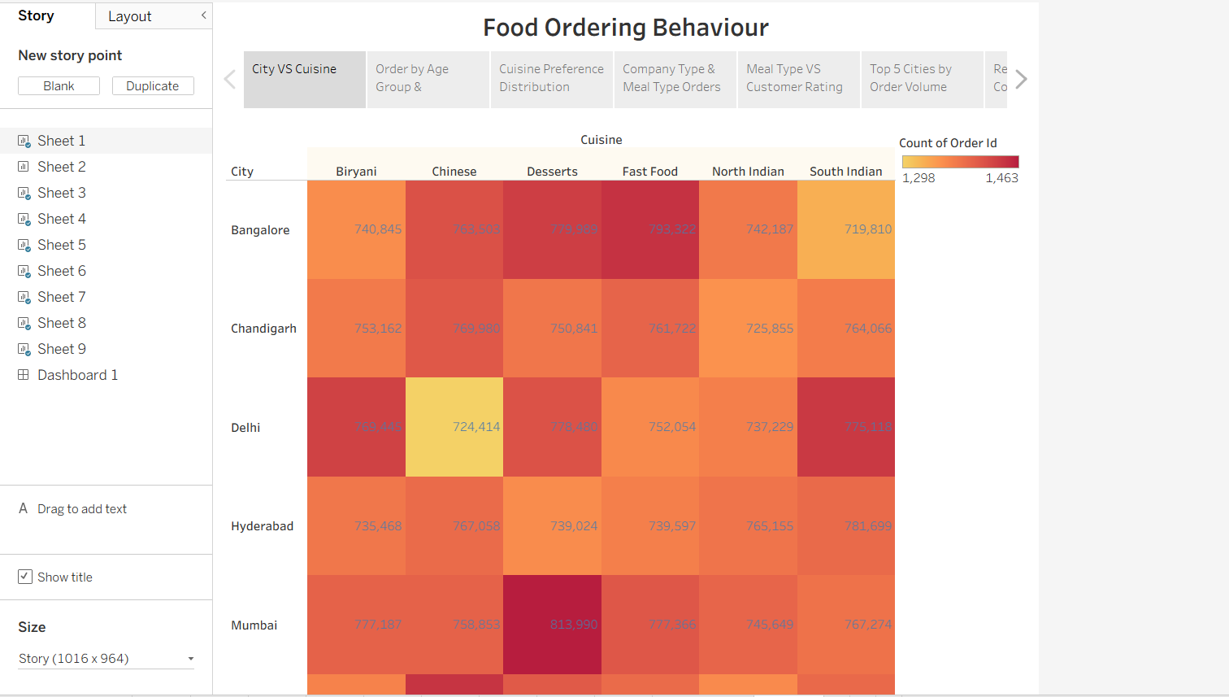

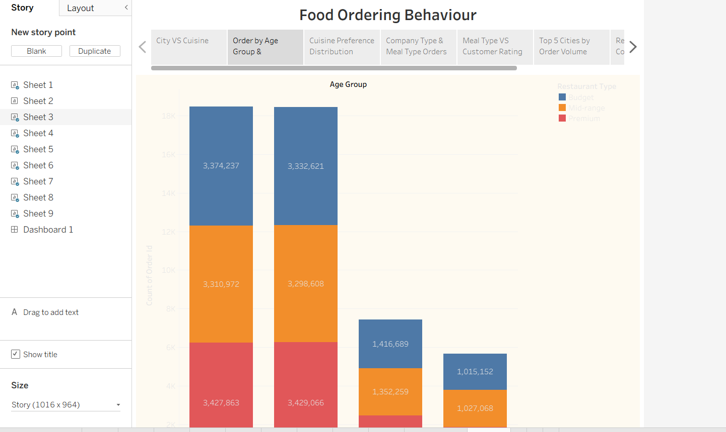

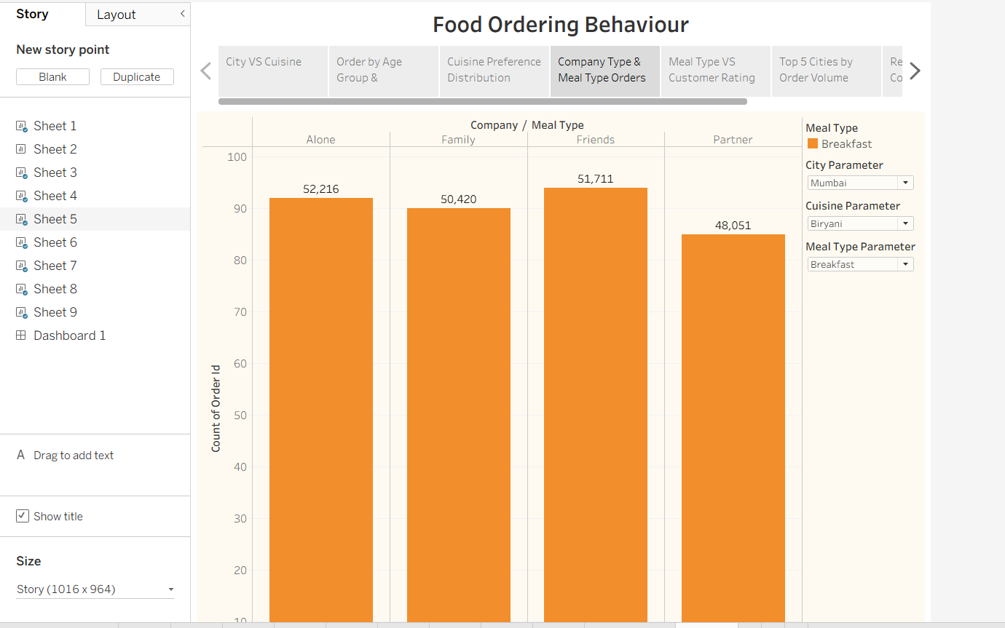

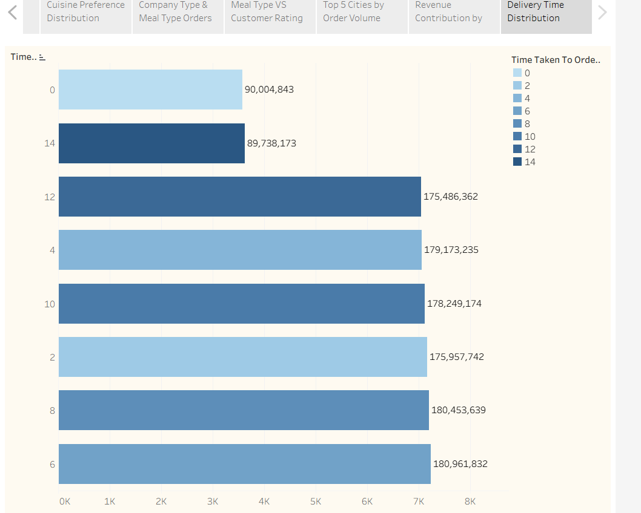
WORKSHEETS:
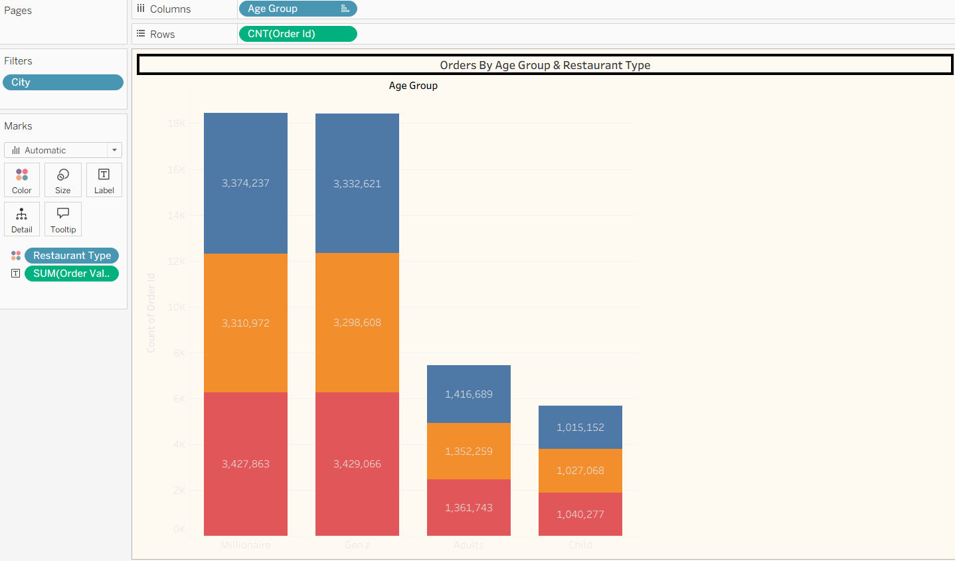

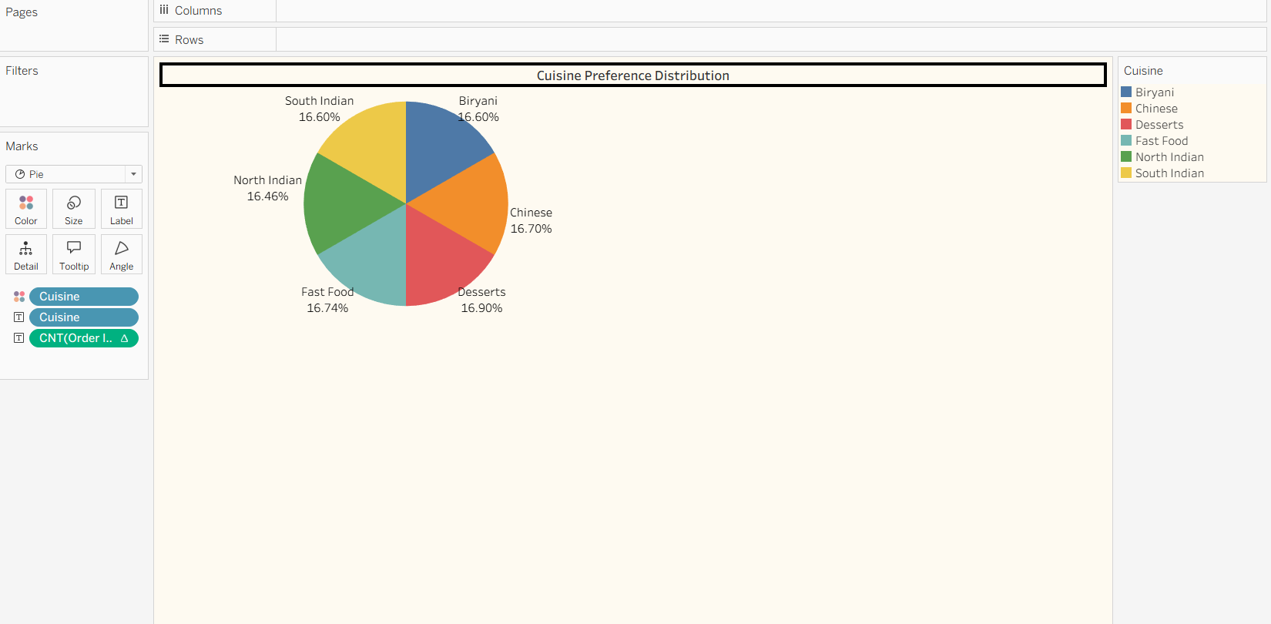

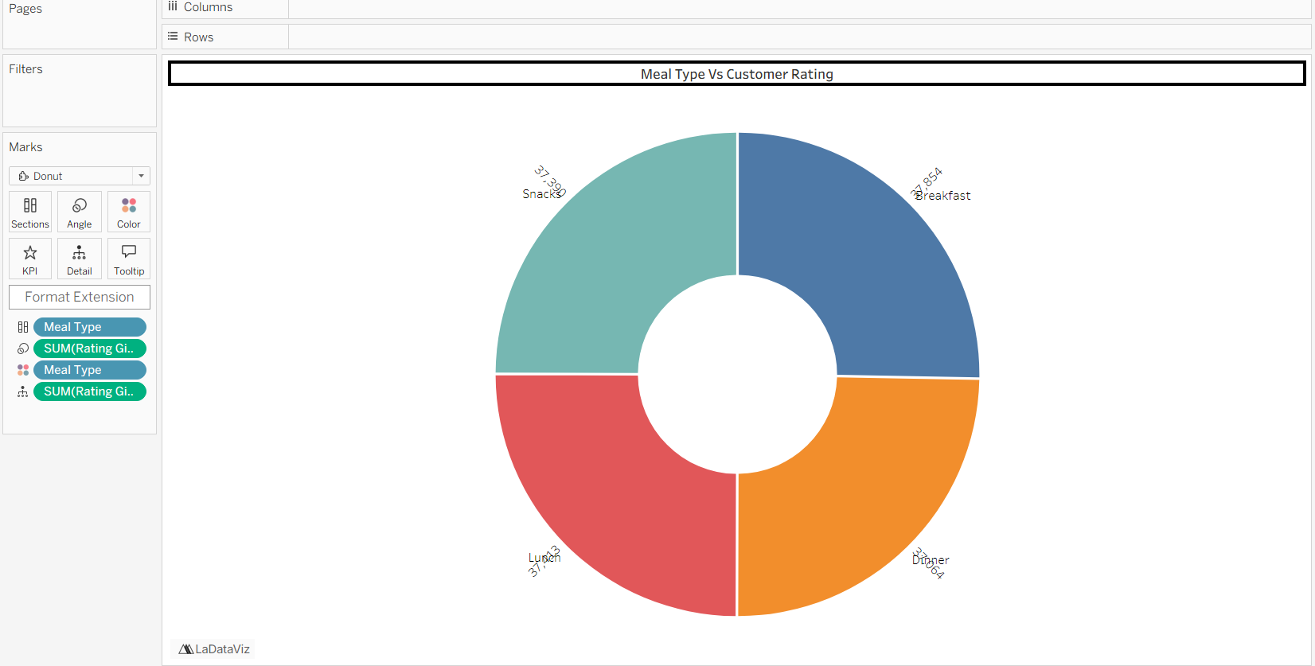

TABLEAU PUBLIC LINK:
https://public.tableau.com/views/Food-Ordering-Behaviour/Dashboard1?:language=en-US&:sid=&:redirect=auth&:display_count=n&:origin=viz_share_link

